It previously did not do the addition of lookalike audience

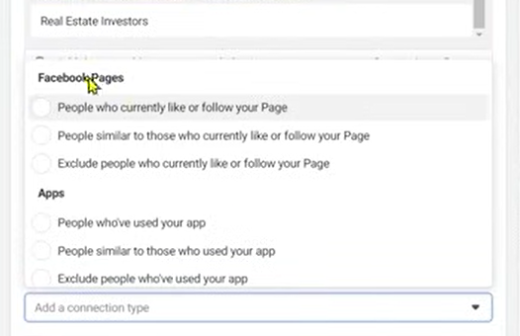

It gives option like above and hey are usually categorized into Facebook pages, Apps, Events

Sometimes through our facebook page we create event through which we ca create audience

So connetion actually help us to create custom or lookalike audience

**Lesson 32:-**

In this lesson we will learn about Interest based Audience

In this particular lesson we will see different ways through which we can collect different ideas for audience targeting Sometimes we come across many big challenges in Interest based targeting topics So in this particular lesson we will see two or more tools through which you can get better result .

The first way is

Finding the pages like by relevant profile

Here you can choose influencer name for targeting who are famous for a particular niche and then target them

Suppose there is an influencer famous for his/her digital marketing content then you can target them so that indirectly you can target there followers

Andthen go to their profile and then try to understand what pages they like

And you can analyse those pages and on the basis of these pages can you do targeting

So for Facebook profile

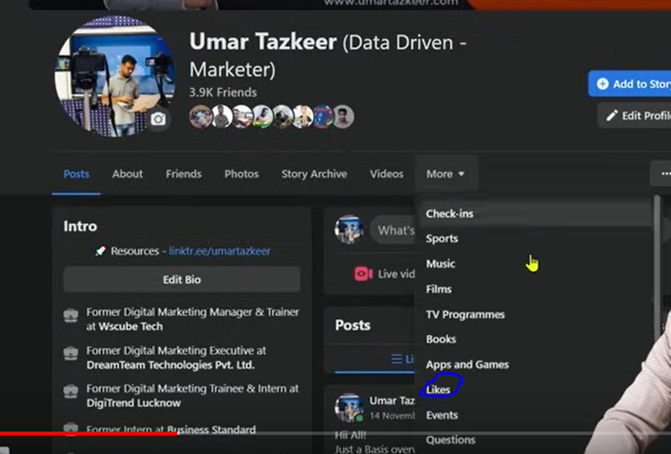

You click on more as shown above and then a submenu will be opened then go to Likes

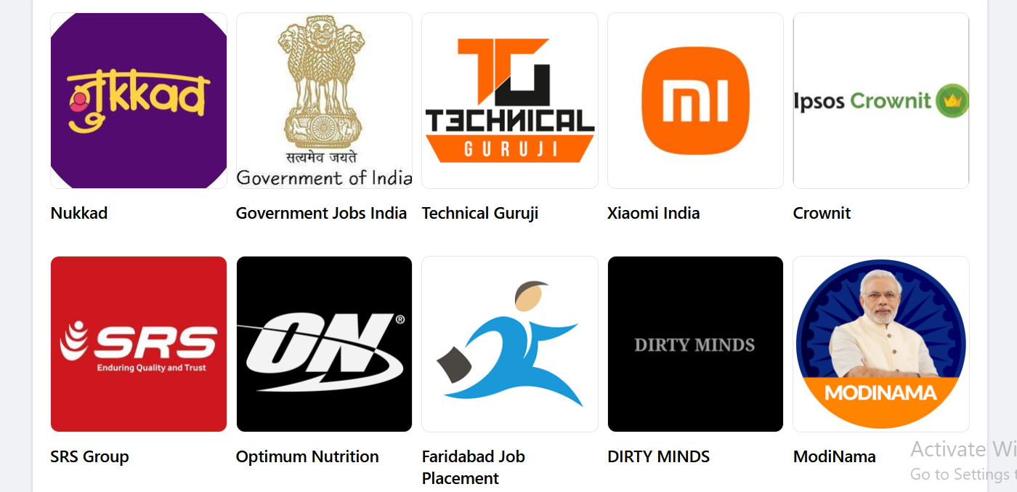Now you can see the list of liked pages

You can search those name in field of detailed marketing if it shows in suggestion then you can target them if it does not show that name in suggestion then you cannot target them.

Teacher is telling this because we don’t usually get any ideas while targeting in detailed targeting so that you can get maximum to maximum ideas so that you can niche down or narrow down you can get better to better audience

The second way is Niche book author targeting

Here if you want to target any particular field then you try to target them on the basis of the author who wrote book on that particular Field

Suppose we want to show ad to the people who is interested in Digital Marketing then we will target a digital marketing author Philip Kotler

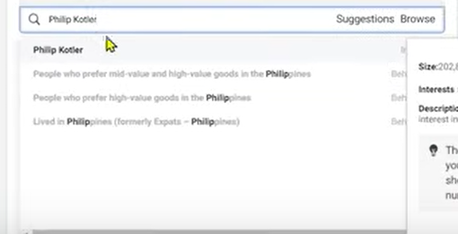

Publishers are not required but you can target authors.

You can target the famous author

Start relting between things

How through one interest other interests can also get targets.

And how one interest is related to other interest.

The more ideas you have of interest the better you can do targeting here.

**Phase 47**

**Lesson 33:-**

In this lesson we will learn about how to find **Hidden Facebook Audience**

Without paid tool

As we discussed tools in previous videos if you don’t want to use them then you have to put some effort and through that effort you can target those hidden interested audiences.

So there are some step provided by teacher but we are actually going to use market api to do it.

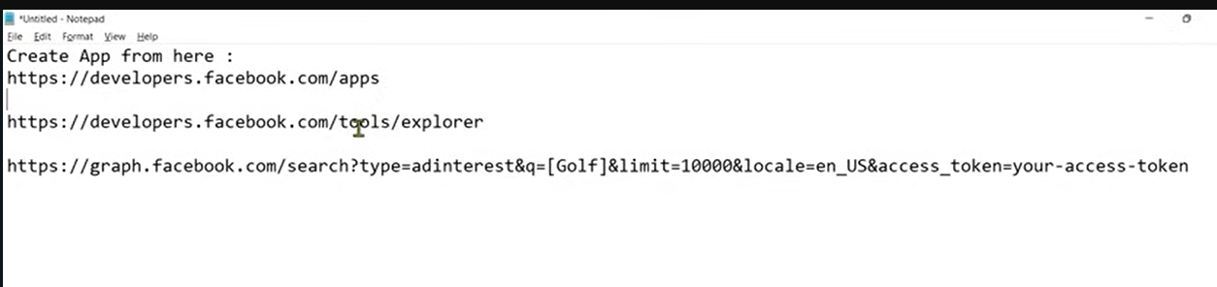

The above link we will use in future

Now first thing to do is to create App.

So what we have to do is follow the first link

But it will not open so follow the link removing /apps from the url

And then register and create developers account.

And follow the above images

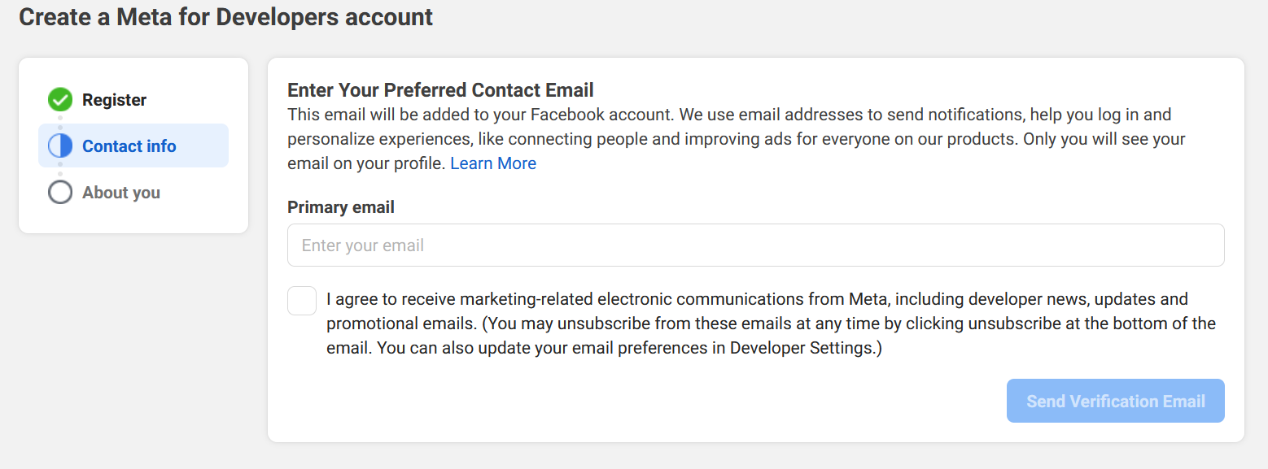

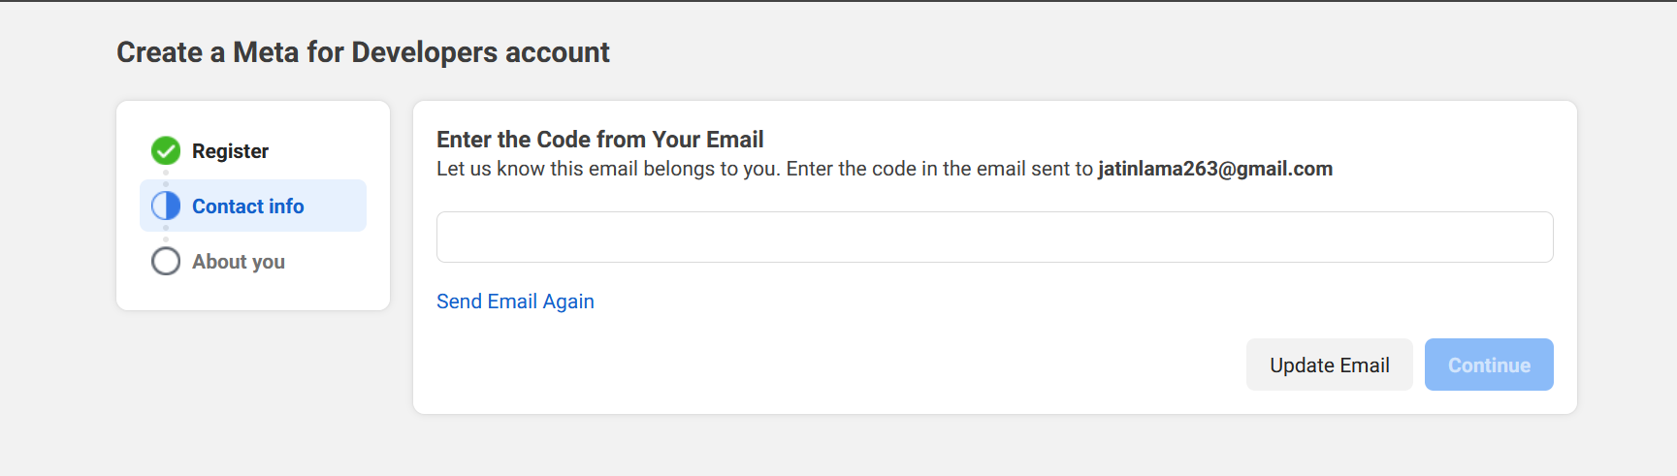

And then it will ask you what is your udentity are you a developer or marketer

After this you will be directed to the first url

Now it will show like this

below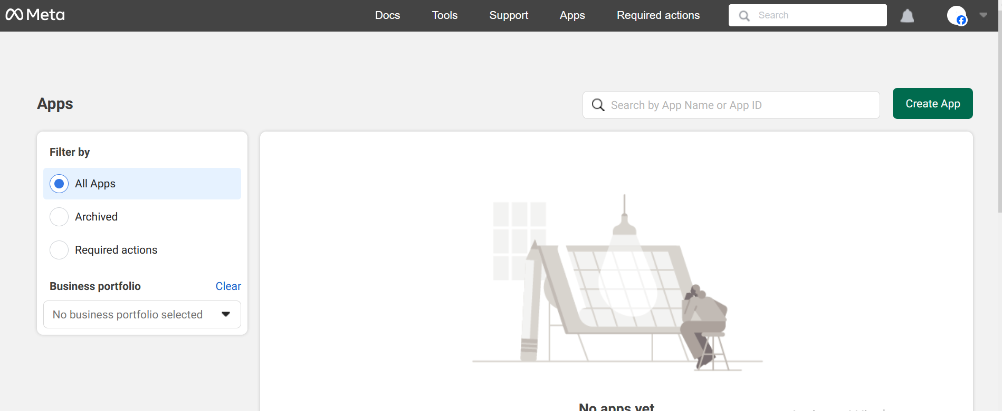

now you just need to click on create app

you will get the page below

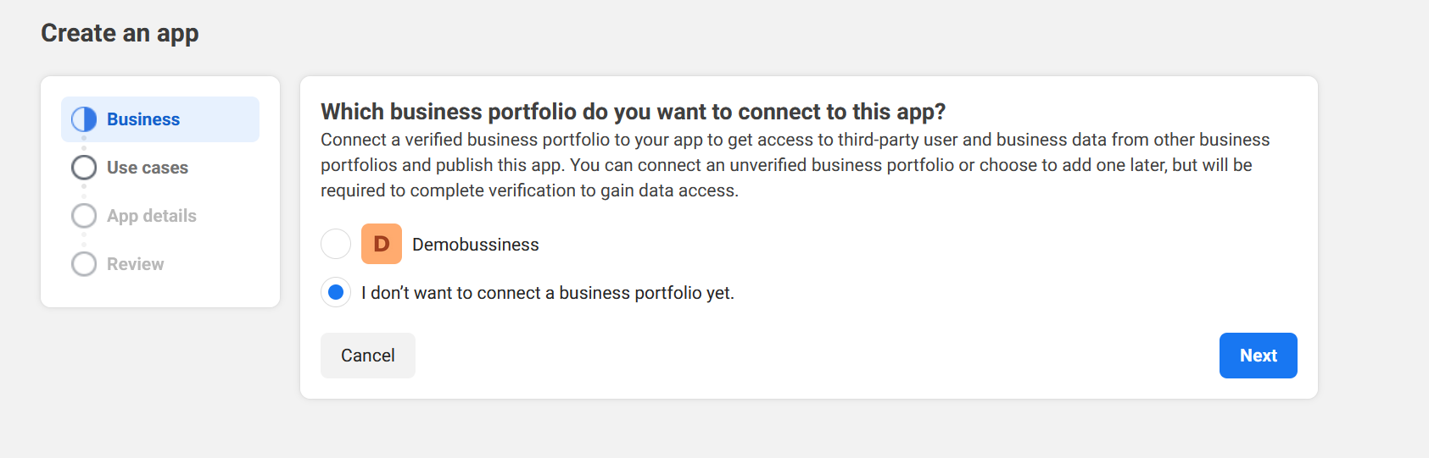

Asking to use Business Portfolio if you have one then check the radio button near it

Or you can click on I don’t want ot connect business portfolio yet.(I chose this)

And in next it will ask you what you want you app to do?

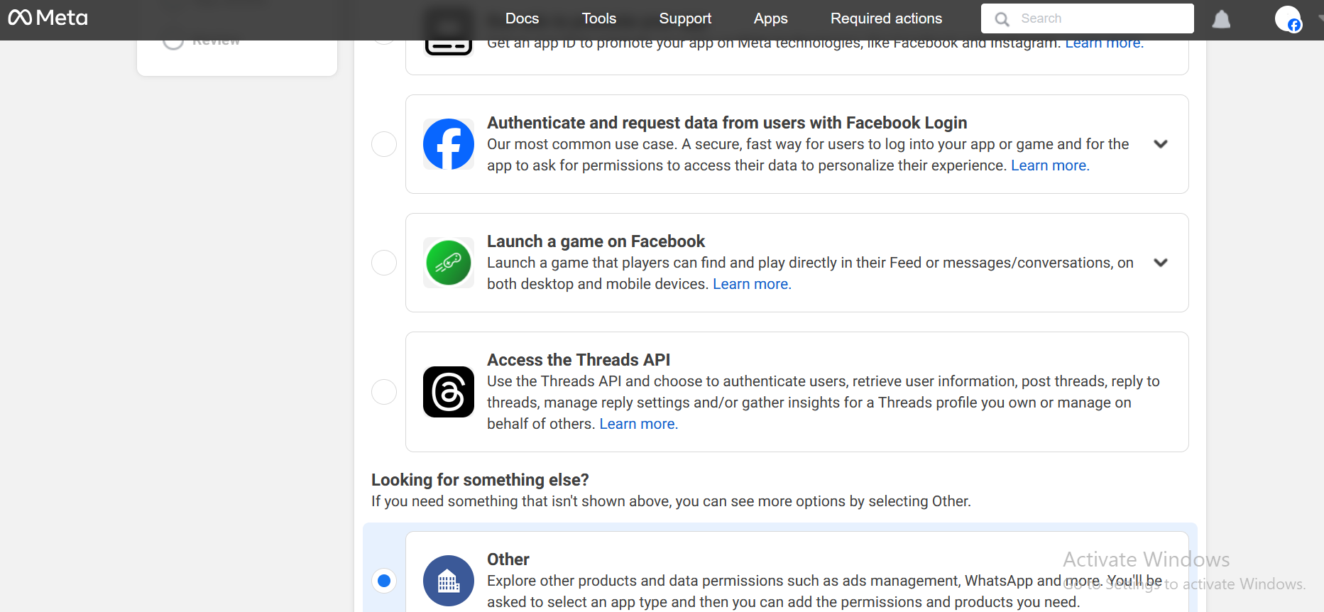

Click on next

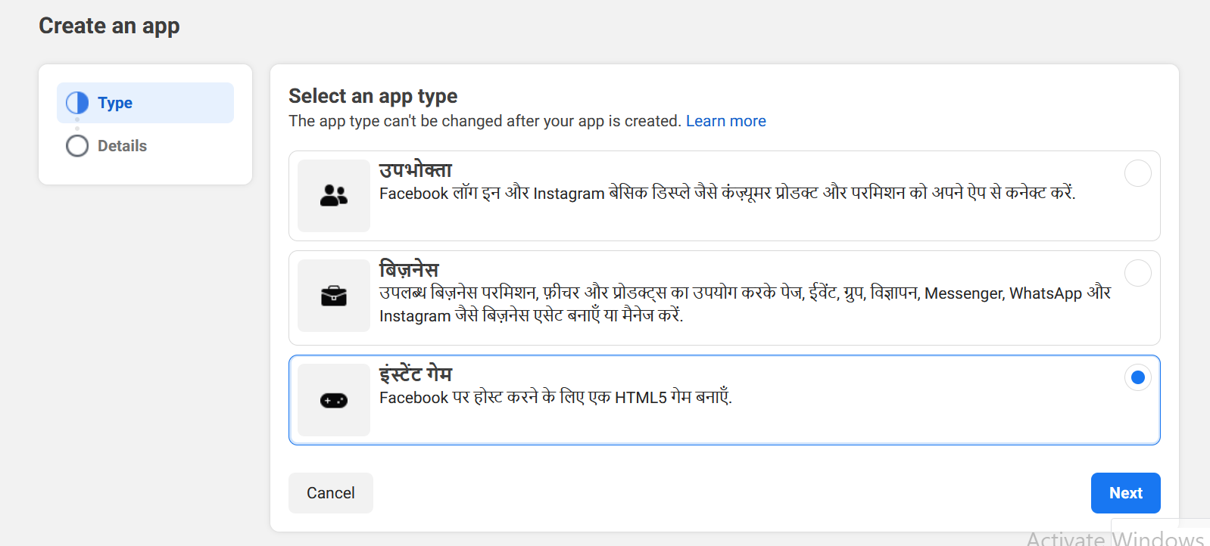

Now it will ask the type of the app you want to make

And give there option

Consumer type

Business Type

Instant Game

we choose instant instant game.

Click on next and now this page will be shown

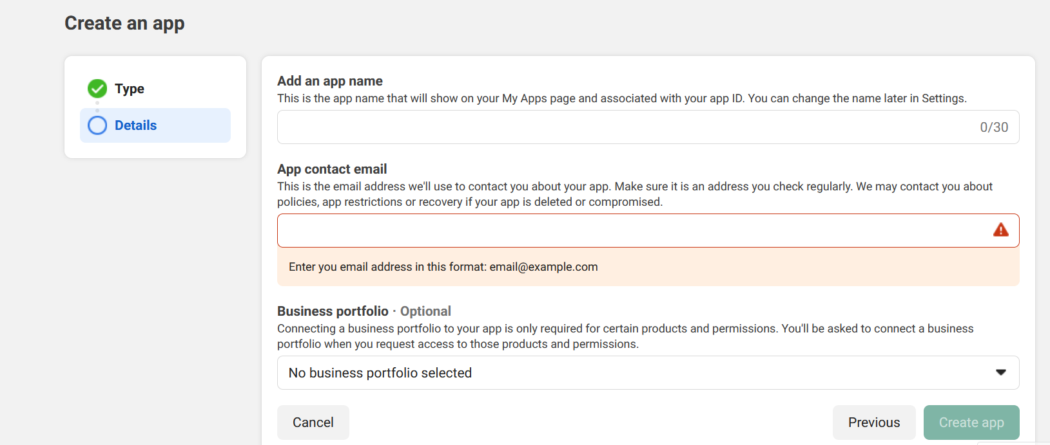

In first field tell the app name

And in second field app contact email

And in third choose business portfolio which is optional

After clicking on create App

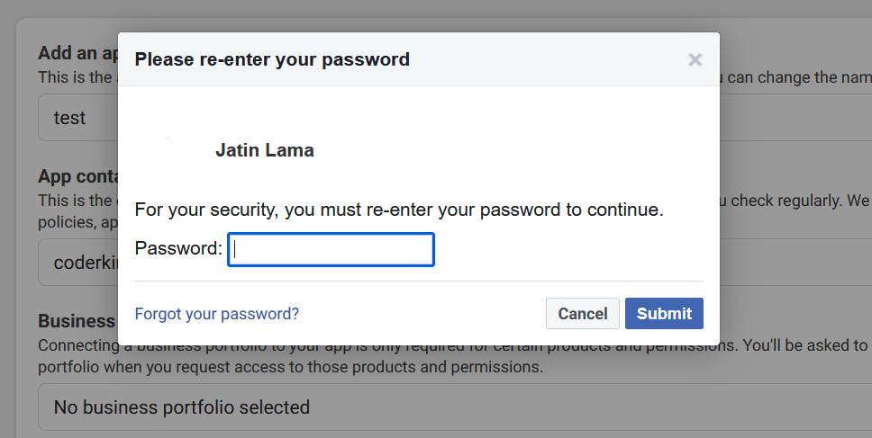

And now it will prompt you to enter the password

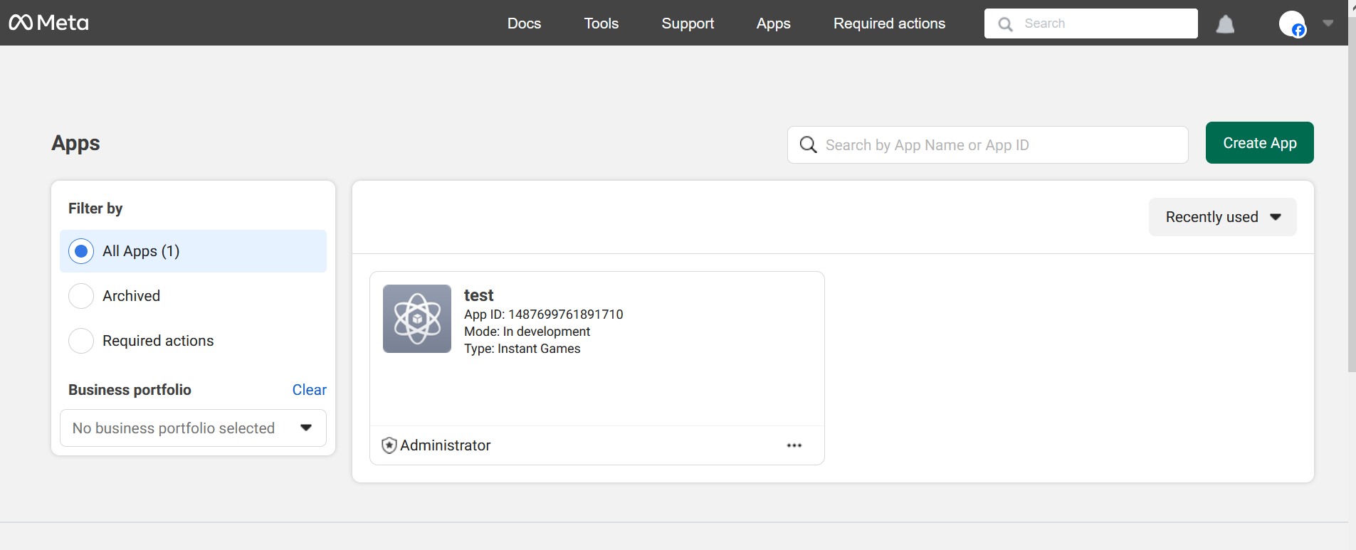

After this your app will be shown in app section

Now go to the url below

<https://developers.facebook.com/tools/explorer>

and you will get the screen below

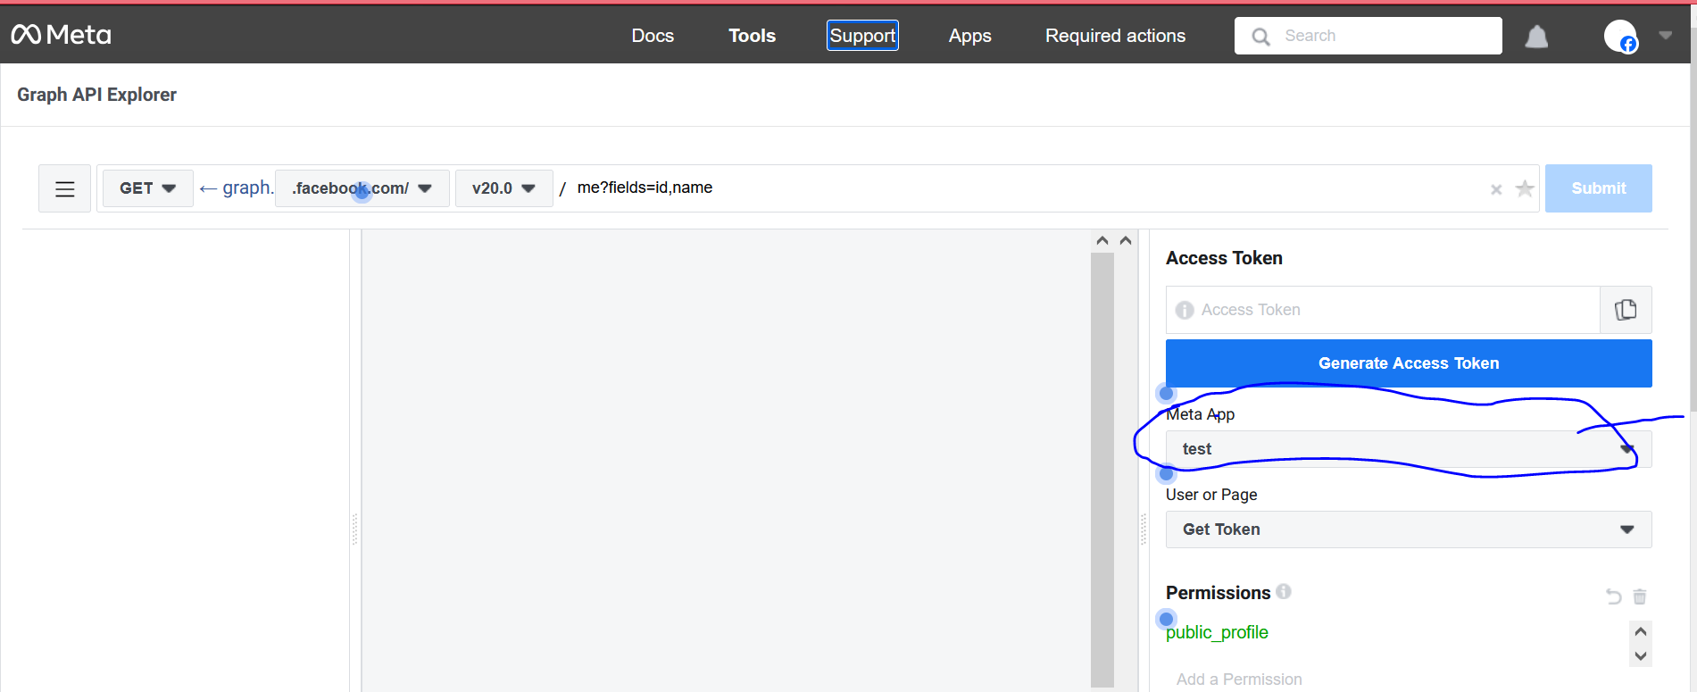

Choose you’re app in above marked

Click on generate Access Token

And you will get the token in above field and then copy it and then paste it in the end of the url below

[https://graph.facebook.com/search?type=adinterest&q=[Golf]&limit=10000&locale=en_US&access_token=access_token](https://graph.facebook.com/search?type=adinterest&q=%5bGolf%5d&limit=10000&locale=en_US&access_token=access_token)

now you will get the result as api like below

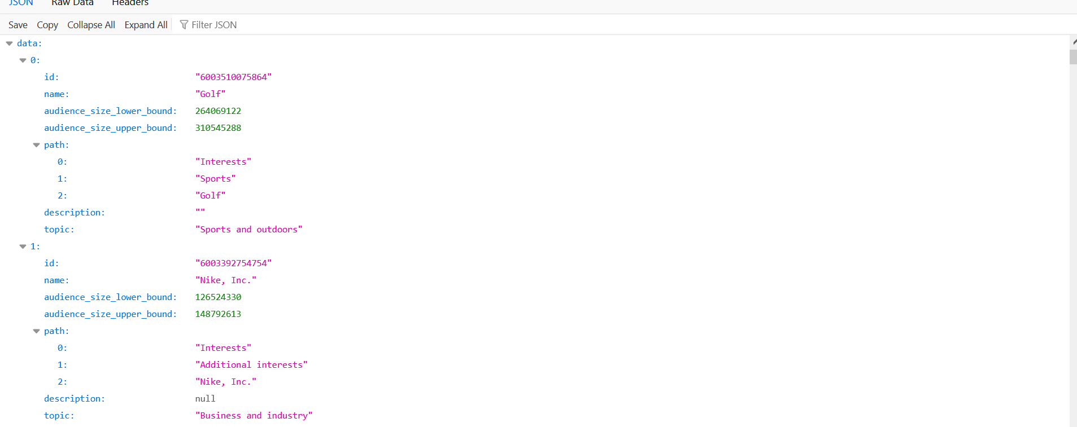

In the above url In place of golf you can keep any primary interest but it should start with the capital letter

It will show you related interest(hidden audience) according to api as above

And now you can use any interest to find there hidden audience  
The paid tool exist because they categorise these interest

You don’t have to do categories api by yourself because them and they make your work very easy.

The more the sources you can collect to find beter and better audience this is good for you and it will also be good for the testing

**Lesson 34:-**

In this lesson we will learn about Facebook Cold audience

What things are better

What are the points or learning we can take from the discussion till now

Follow these points a guidelines or you can say it some rule of thumbs that have been finalized from our discussion till now related to audience

The first point is Don’t be too narrow and don’t be too Broad

Means your audience should not be less than 1000 and your audience should be in green spectrum in estimation sown usually shown on the right side of page.

If you become too broad then there is a chance of your ad reaching irrelevant ads and if you want to become too narrow then you will not be able to reach right audience and you will not get right impression or your cost become too high So moe with average audience size

Point 2

For starting campaign when teacher do targeting overall india then if he get 5 lakh to 10 lakh audience then he move forwardso you can take idea from it and he is telling it when all these things have become successful for him

This size is fine for him and he have seen whenever he give performance by this then he did not get any problem in size of audience may be in custom maybe

CTR

Clickthrough rate (CTR) can be used to gauge how well your keywords and ads, and free listings, are performing. CTR is **the number of clicks that your ad receives divided by the number of times your ad is shown**: clicks ÷ impressions = CTR.

Point 3

Always try that your CTR should be atleast 2-3 percent

CTR is not initial metrics actually

Means when we try to make audience then we don’t talk about CTR

It will be talked after when your ad will be run and your ad start serving

Then make sure the CTR you get is relevant or not.

Means if you have chosen broa audience then how CTR is coming it give you that insight what type of audience you have targeted

Point 4 run the ad atleast 3 or 4 days or let it reach 3000-5000 people to understand anything

Many people do this thing that when they run there ad for 1 hour they immediately see there insights and then do immediate prominent change in interest but that way the algorithm will not able to learn or system will learn and nether you can test anything whether you r audience is right or not or creatve is right or not So wait until you have enough data so that you can work on it Don’t take decisions.

**Phase 48**

Until you have data of 3000-5000 people and you have run ad for 3 or 4 days. When your ad will not be shown to the people then how will you take the decision

If you have high budget and you see the performance and get some audience then you get the insights that the things are working or not , creative are working or not ,Are your audienceset working or your different ad group are working or not

The 5th point is that Test different types of targeting

Whenever the teacher runs the ad he does not rely on only single audience

he make as many audience he can make and then test in different different ad set

Don’t worry if you do it in starting but you can keep the audience after making them

In facebook ad set we see the audience section you save it from here

Whenever you are free you use his audience to test again

Once you made the audience don’t think about the audience your are switching between different creative and testing different things it is not going to work

You have to do testing with audience especially in facebook ads

The 6th point is Change the ad copy if your frequency reaches more than 3 or 4.

If people see your ads many times then it create a condition of ad fatigue. To avoid ad or creative fatigue you follow a metric that your ad should not be shown to the same person 3 or 4 times If that person sees why ad three or four times and he does not do reacting to it means right signal is not going to the algorithm or machine learning system and gradually ad performance decreases and it will treat your ad in quality metrics as negative and it will ot give that thing too much value. Then from that point of view our concern is that we should be protected from ad fatigue then we make sure that our ad should not be shown to the same person two or three times if so then it is a problematic thing so to be saved from it we keep updating our ad copies regularly

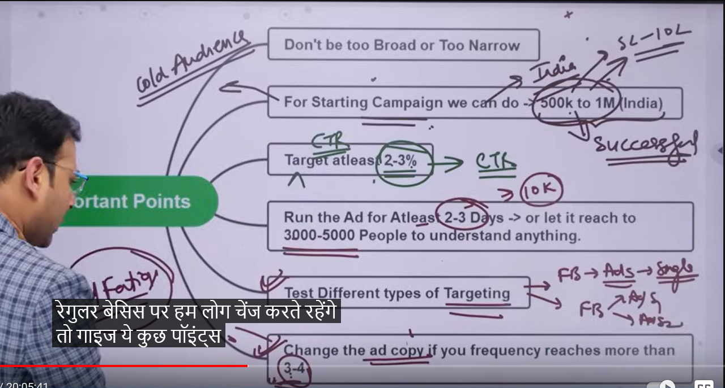

So these are the points of whatever we have talked about the audience till now.

**Lesson 35:-**

In this lesson we will learn about **How to write perfect ads copy**

If we talk about ad set level settings we have explored many option and settings there What are the things and how can we do audience targeting Now if we go by flow wise the next important thing is ad copy. The actual copy that will be shown to the people that is also very important and we have to focus on it

So we make sure here whenever we make Facebook ad account then the third level we have and where we make our actual ad creative what are the element there and how can we start

This topics is slightly related to copyrighting

If we talk about it talk about copyrighting then it is itself in in depth topic with regards to facebook ad it is indepth

So in future teacher will tell us about the copyright modals or framework

And we then use these framework to create our ad copy.

But first we need to see the elements we see in this level and what are the things we need to keep in mind means when we make our ad then what are things we need to collect what are the element you should have and then by uing that element we can create a better ad copy

Teacher is saying that this section is basically divided into two section

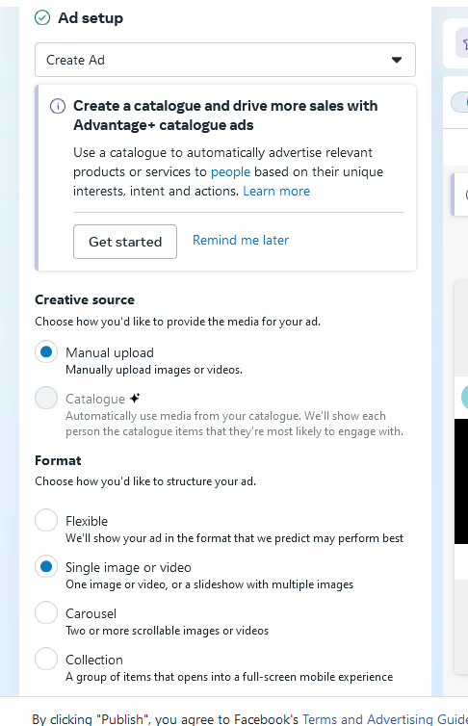

First we need to choose our format for example if you want to make a single image or video or you want to create a carousal if you want to you can make a carousal with different variety of combination of image or videos

Then we have collection type of format Mostly used format is single image or video so for now we choose single image or videos this is one section

Then the image or video we choose. what we see element related to it

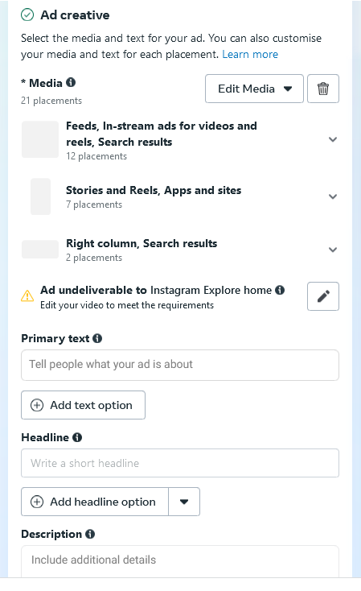

We see that there is that is primary text

It is the text you see above your creative 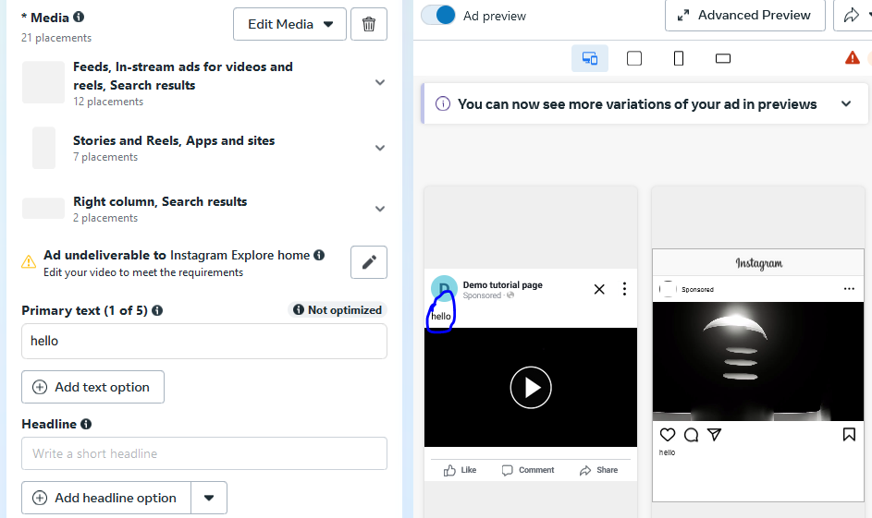

And in headlines you see the text below the creative

And yoy see the decription below the headlines as marked below

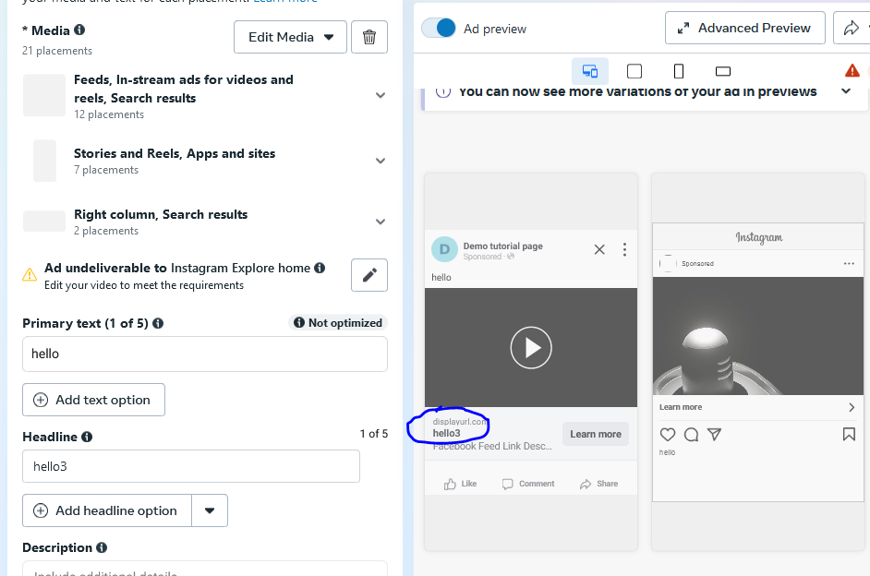

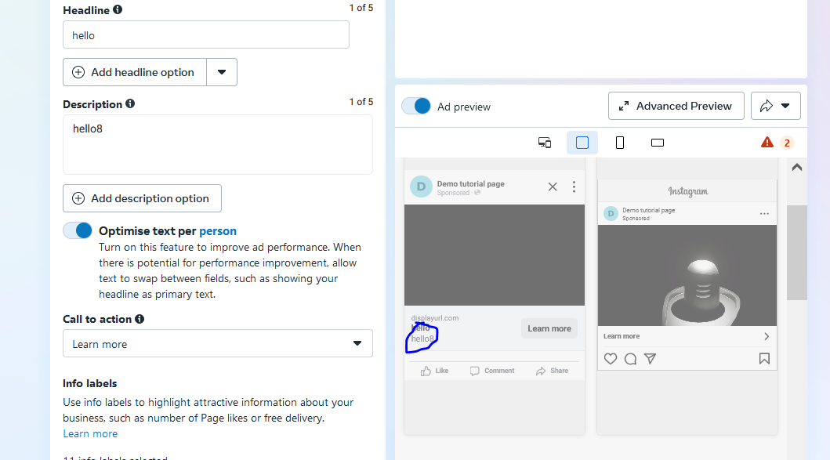

We also get option for our call to action button as you can se field of call to action

The most important thing is how we can write our primary test

First we discuss it firstly

What are the bullet points or things you need to keep in mind

There are three things our primary text need to have

First is hook

Basically people going to facebook is not coming to just see your ad

There just scroll and come across many ad then why should they click on your ad.

There should be attention grabbing or hook in our image or video

And by seeing that image it stops scrolling

In primary text it should have a hook type elements inside it

Which you thing It is an attention grabbing thing

And there should be something in text that when out targeted audience see iut they stop scrolling

Then we have story which is telling more about your story

Then the other thing is offer

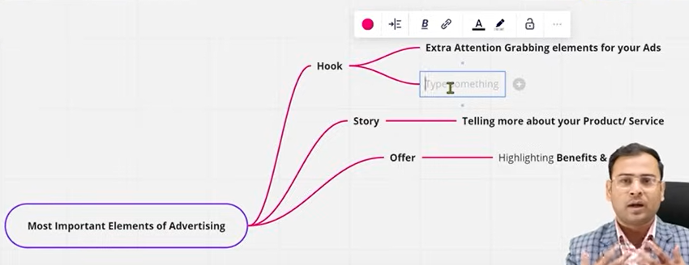

Why should they watch your ad and landing page amd why should they purchase your offer so give offer to them

It is recommended to make customize offer whixh ou need to use for your app

If we talk about what are the things we can collect and keep inside them that is hook , offer, story So suppose if we take an example of hook then if we are selling digital marketing consultancy or google ad services

Who could be the your service consumer they could be business owners

The primary could be business owner

It is an example of hook type that does not mean hooks are of this type

Anything that can grab the attention of the viewr in facebook that is called hook.

**Phase 49**

If we talk about hey business owner

If I mentioned hey business owner hook in primary text then obviously we are targeting those people who are business owner

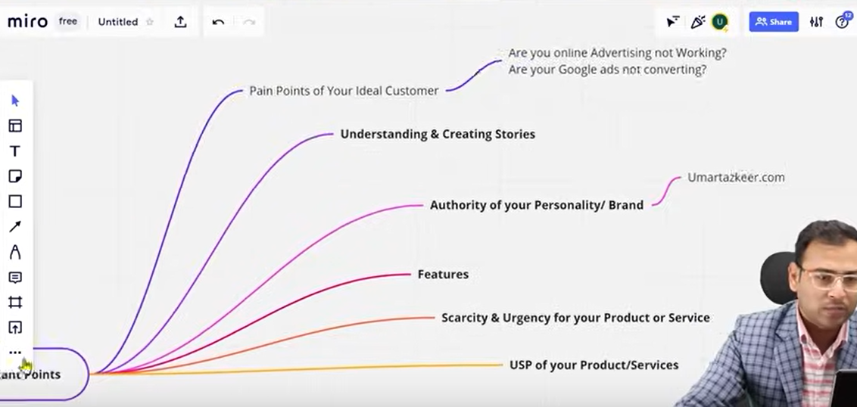

Now suppose if we are running ads for kindergarten schools then in that particular case to attract those prospect and directly approach them we can mention hey parents

Similarly for stories we have to tell here that what our product or service actually is and what it is used for How it is usefull.

And now if we talk about more important points How will we use them teacher will tell us.

Different different models we have How can we use htem and how can we create a perfect ad copy

If you are creating an ad but this lesson is important for the point of view if you are creating an ad whether we have these points or not.

So first point is

**Pain point of your ideal customer**

We again take example of business owner google service

Then how we will address their paint point like

“Are your online advertising not working”

“Are your google ads not converting”

So we can mention some pain point like above.

That’s why teacher told us about the buyers persona

Until you don’t know about the prospect of your audience then how will you know about their pain points

2nd point is **Understanding and Creating Stories**

3rd point is **Authority of your personal brand**

Authority can be our already proven client results, our reviews ,number of clients you dealt with, How much revenue you generated for your client etc

I think it is a proof that you are genuine

Every brand have different authority

These authority points should be proven

If the user search about your brand or reach your landing page then these points should be justified

4th point is figuring out all the **features of your product** and services and then write them together because these things will be needed when your write your ad copy

5th point is **Scarcity and Urgency for your Product or Service**

Sometimes to trigger sales and trigger leads or increase the visits of landing page then you need scarcity and urgency elemnts like “offer ends soon” or “offer expiring soon” offer ending in ten days you can use such example related t your project

6th point is **USP of your product**

Whoever wants to know your product or service then how it is unique will try to know it.

So write about the USP (unique selling points) sepeerately.

We basically we use these points in our ad

We have different elemnt of ad that is Headline, Description

We use these point in our elements

We have to see whether our images are matching with our elements

The way we have done our audience targeting whether elements are matching with them or not.

If the user click on this ad or reach landing page then is there any uniformity or not

If we are showing

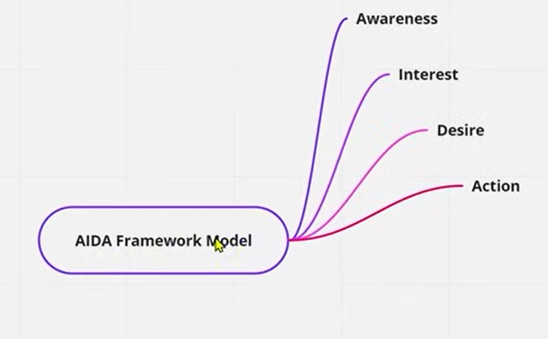

If we are showing right ad to right audience and whether they are taking them to right landing page or not

So all these things works together

So when we talk about ads then many variables play a role .

It does not mean that if you know how to make good audience then you will get success , or if you know how to make cirrecet ad copy then you will be successful

There are many things that together do there work

**Lesson 36:-**

In this lesson we will learn about **How to write ad copy | AIDA model**

So we are going to understand what is AIDA model and with the help of this how can we make better ad copy

In the last lesson we discussed is that when we write ad copy before writing what are the things we have to prepare or do homework and check whether these htings are with us or not

And according to our requirement where to keep it whether in primary text , headline, description.

In previous lesson we did not see any example how an ad copy looks

And Teacher has told us that there are many frameworks and models by using whom we can create better ad copy

So in that we are going to talk about AIDA model.

So its full form contains following points

1. Awareness
2. Interest
3. Desire
4. Action

We have to make sure that these elemnt are In pur ad copy so that we can attract our prospect and build interest in his mind to the product then comes desire nd then there comes action.

Now by using those we are going to write our ad copy

Now teacher is going ot show some ad copy

Where all these things are used. So that you get an idea that how you can make AIDA based copies

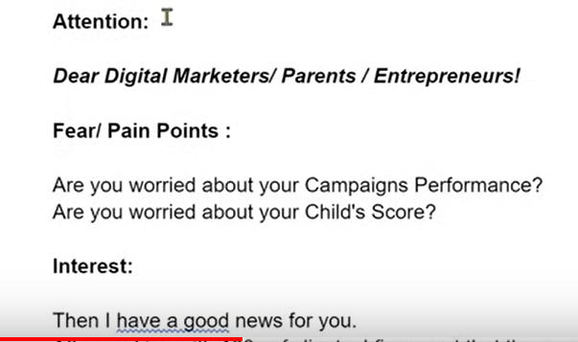

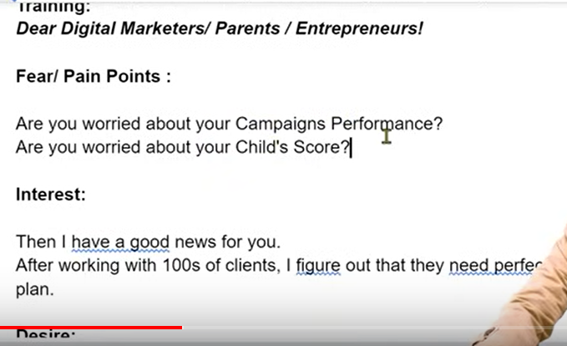

Now in above image example teacher is promoting ad of training digital marketing there is hook like “Dear ..”

And then pain points we have audience problems discussing

It all come under awareness

So first we show grab peoples attention by hook nd then show them their pain points

In pain point we are targeting people with their dissatisfaction with their

Compaign performance

When the audience will agree with pain points then they move forward in the ad

Then comes interest phase

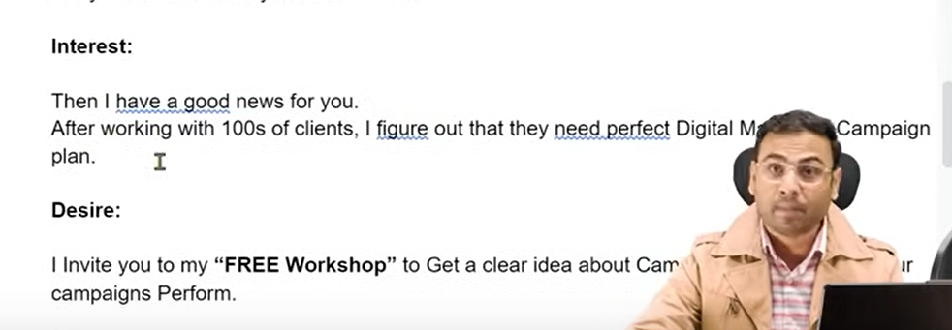

You can see example of interest phase above we will try to bring interest to our adby giving them hope that their pain point can be solved

If they get effected by interest phase then move forward to desire phase

Desire simple meaning is that whatever activity or serviee you are offering what is the output you want from the eervice

So here we are addressing the audience desire

Now we go ahead with action

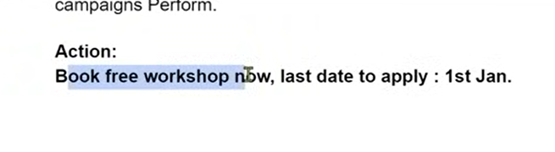

In above action phase teacher has used FOMO or urgency by telling the last date of 1st april

So you have to first ready these ingredients means you have to find pain points or content related to AIDA

If you have these contetnt hten you can create better ad copy.

This model provide us ease and provide us different phases in our ad

**Lesson 37:-**

In this lesson we will learn about **How to write ad copy**

**Phase 50**

In AIDA model we understand that first we have to do awareness ,then invoke interest and then we have to cater desire point and then we have to do call to action So this was the structure of AIDA and we used to write ad copy through this

Now we take an example of real estate ad.

Lets say we are running an ad of apartment and we want to book it through facebook ad

Does AIDA model work there .no

Because here I cannot invoke interest in someone that to buy the apartment

For things like 60-80 lakh none can invoke interest in it. Because the person uy that thing oce in his lifetime so he will take lot of thinking to reach his decision

So here our AIDA model will somewhat fail

In these cases we have to use the direct sales or ad copy

Teacher will also shows us direct ad of real estate

So it will be difficult to add AIDA in case of real estate

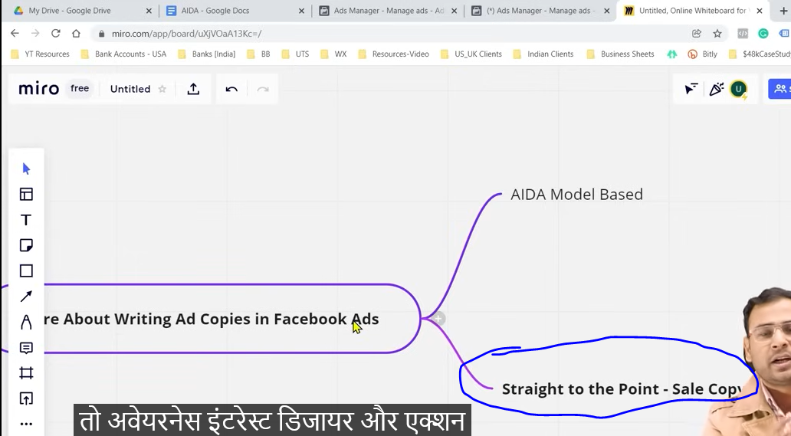

So what to do we understand by the straight to the point-Sale Copy as marked above

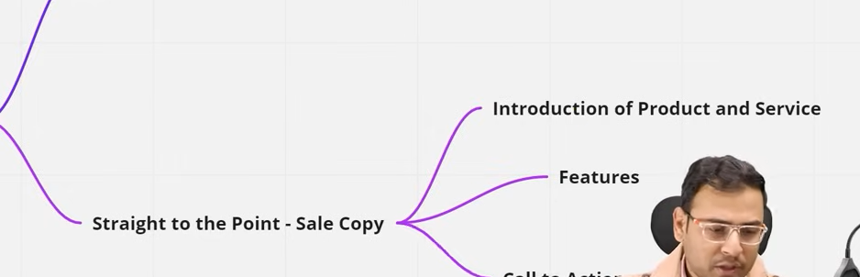

In these three point come

1. Introduction of product and service
2. Features
3. Call to action(which mean are you saying them for booking or give free tour )

So sometimes AIDA model does not fit in some business nature.

So you have to understand what type of approach of ad copy you want to us ein what type of business

You have to decide that

So if we talk about straight to the sales ad

So lets take an example of property ad like below

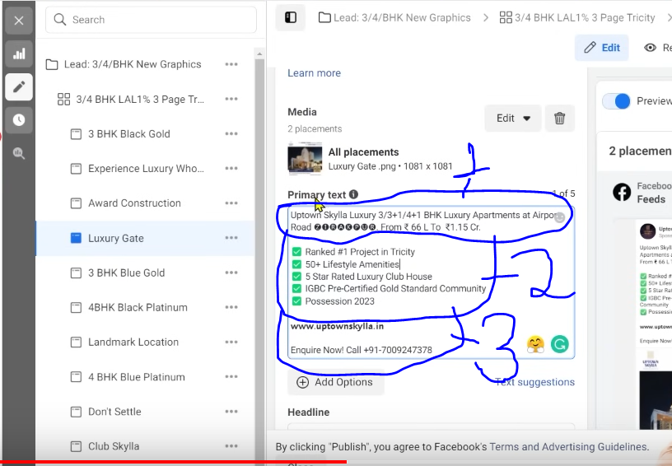

In 1 marked is Introduction of product an services

In this we have also clearly mentioned the prize range because many people search for 30 lakh, 40 ,70 lakh flat so we have mentioned it in starting that it is a luxury project

Then there comes the feature marked as 2

Prospect basically sees it and try to understand it he has to understand sometimes that what will be the location is there any parking facility does the owner get the approval

Wha will be the date of possession

This type of feature is eeded by prospect and on the basis of that he move forward

It is not like you will woke interest in them you are not selling tshort actually where you will invoke interest and sell it

So when there will be requirement then he will buy it.

And now there is call to action in marked 3

So this is a simple ad copy example

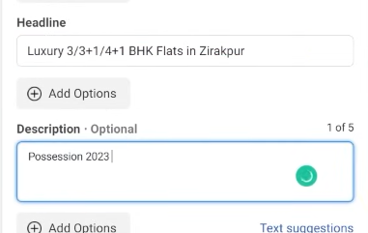

There is also given headline where a feature is mentioned here

And then in description there is possession date because people are worried about when they will get the possession of apartment.

We can also add starting cost in description

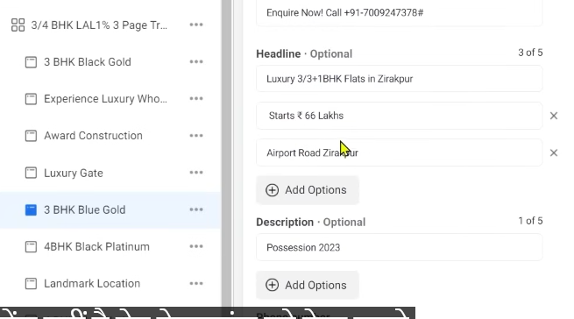

In our another ad copy we have tested different headlines

At least write 5 headlines in your ad if you want to genuinely do testing otherwise your ad copies will stop performing gradually because you don’t keep variation in them (maybe) So it cannot test algorithm with different combination

Now we will see ada model ad copy

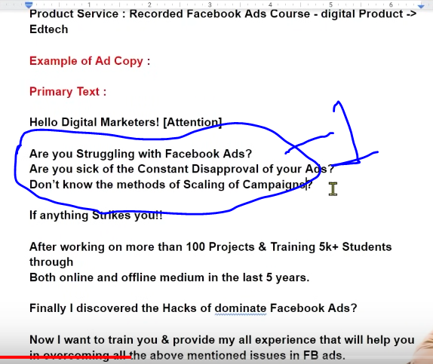

Lets say we are selling recorded Facebook ad course

If we talk about categories then it comes under digital marketing and inside it ed tech

Now if you see primary text we are saying hello digital marketer

That is attention element

And the above marled one is pain points

Before selling the product we have to address the pain points

You can also write emojis in it

Now by “If any thing strike” we are actually putting the connect(who knows)

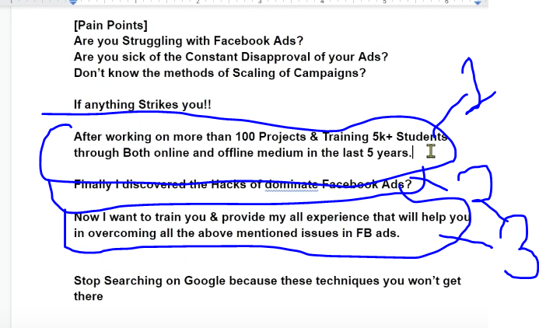

1 marked is Authoryity

2 marked is Interest

3 marked is desire

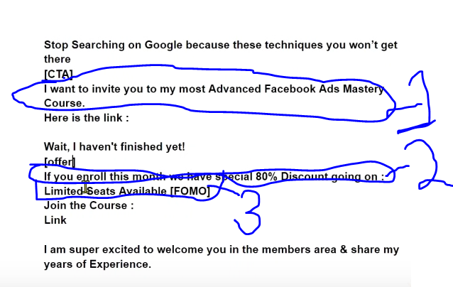

The 1 marked is Call to action

The 2 marked is offer

The 3 marked is FOMO

You have collect these element before writing ad copy You can test different variation of your element in different ad

You have to work on it.

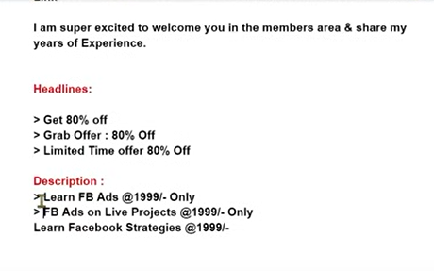

Now this the healine the teacher has wrote.

You will mention above when your price is very competitive(msybe text is talking about description )

But don’t type above if you have high price it will not trigger them to call to action and your call to action is beside the description

The last two point of description is convincing the audience

Always make your ad copy readable

Don’t like it a paragraph that it became unreadable

Now if we put the text in primary text in ad copy then it will look like below

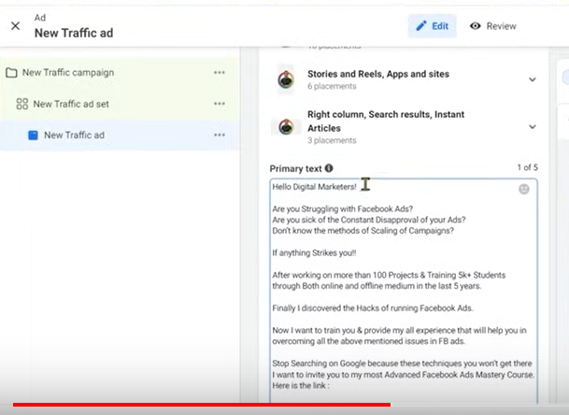

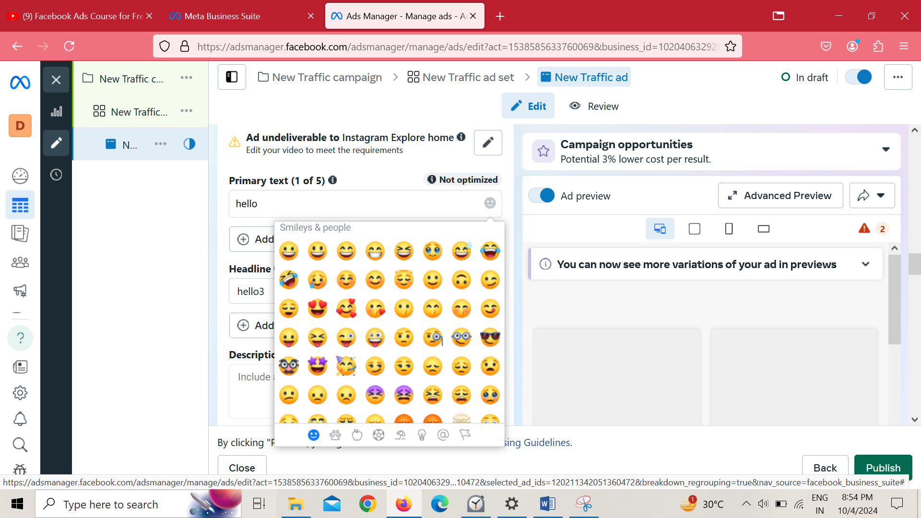

**Phase 51**

By clicking on smiley in primary text field you get different option of emoji

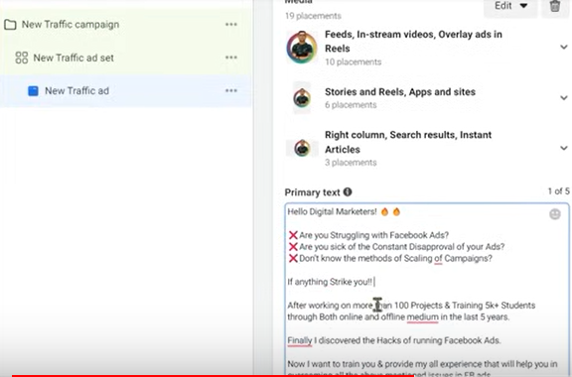

After adding emoji it look like this

Don’t overuse it that it looks too much funny

Make sure use optimum number of emoji

Then we have to mention Headlines

So we have different option of headline as marked below

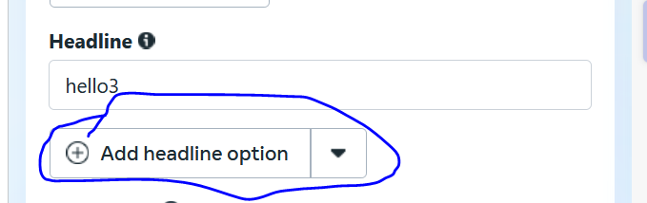

We can add head line like 80 percent off and we can click on add headline option as marked above then new textfield appears where you can additional optional headlines

The text can contain grab offer 80 percent off like below

